Weekly Summary 19/11/2018

Downloaded and trained ImageNet ILSVRC12 dataset <http://www.image-net.org/challenges/LSVRC/2012/>

It was used to train the default GoogleNet models, it’s about 100GB and over 1000 classes. After training, the dataset was divided into 12 core groups that may be more practical to use than 1000 individual classes.

Groups are ball, bear, bike, bird, bottle, cat, dog, fish, fruit, turtle, vehicle, sign

loss and accuracy

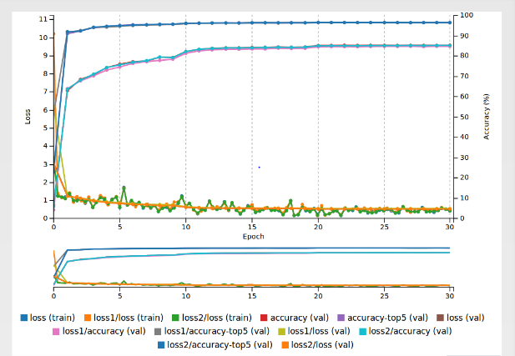\

Two image tests:

Before

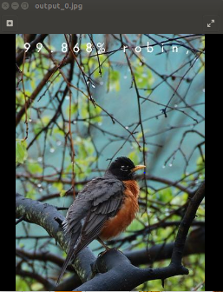

After

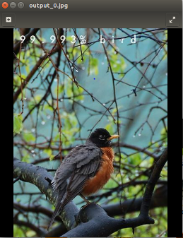

Before training, this image is identified to a robin bird with 99.868% accuracy, after training, the image is classified to bird that increase the accuracy to 99.993%.

Before

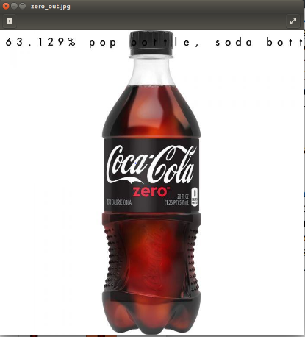

After

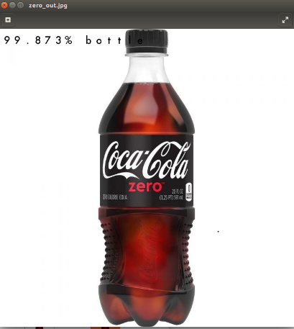

Before training, this image is identified to soda bottle but with only 63.129% accuracy, after training, the image is classified to bottle that increase the accuracy to 99.873%.